CORVI  
THE PANDEMIC VIRUS

Corvi is a game stationary where the player controls SuperDoc, attempting to fly in the given spaces and dodge the virus that Corvi fires. Sucuano developed the game over the period of several days caused by the Covid-19 pandemic, using SuperDoc as protagonist.

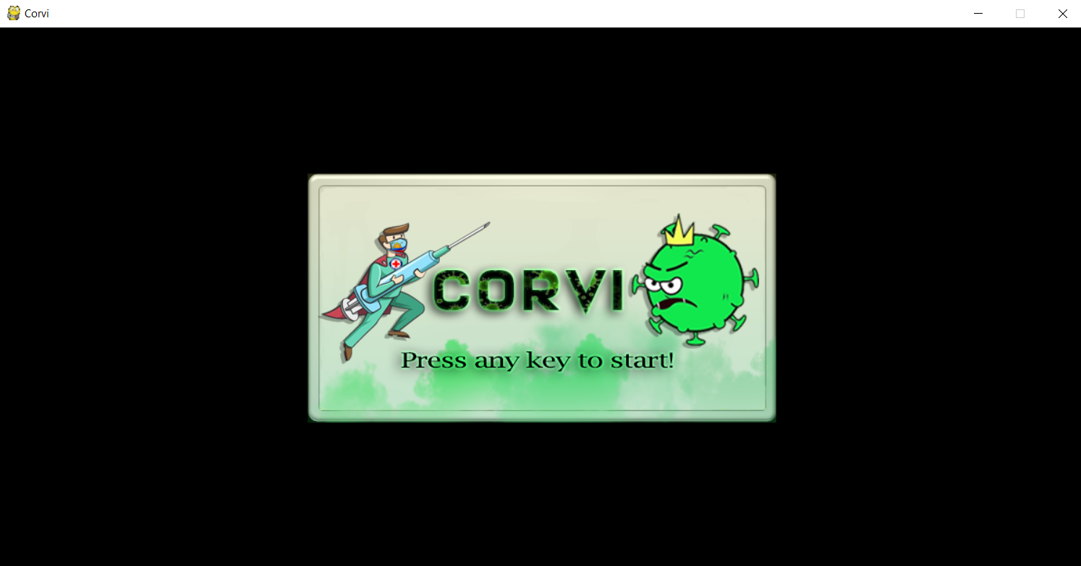The objective is to direct a flying doctor, named “SuperDoc”, who moves continuously, between spikes and laser. If the player touches the spikes and laser, they lose. SuperDoc briefly fly upward each time that player taps the “UP ARROW” on the keyboard; if the up arrow is not tapped, SuperDoc falls because of gravity; each virus that he dodges the player earns a single point, every 10 points the laser and spike moves to make the space tight.

